  II- Comprehension | 10
- Read the following passage carefully the answer the questions below:


One day, I was standing outside an underground station in London because I was waiting for a friend, when I saw two men. One was sitting on the pavement. His clothes were old and dirty. He had a hat in front of him. As people passed by, he said, “ Can you give me some change, please ? “ a few people put some coins into the hat but most people ignored him.

The other man was wearing a suit and holding a plastic petrol can. He stopped people and

told them his car had run out of petrol and he had forgotten his wallet. He asked them to lend

him some money for petrol. Most people happily gave him money. Some gave him coins, but

most gave him notes. I watched him for ten minutes. In that time, he collected a lot of money.

He put it in his pocket, but he did not go to the petrol station. It became clear to me that both men were beggars. The one in the dirty clothes needed money more than one in the suit, but the one in the suit was much more successful. Isn’t that strange?

- Now, answer the following questions in complete sentences:

1- Why was the writer standing outside the station ?

……………………………………………………………………………………..

2- Did the other man go to the petrol station?

………………………………………………………………………………….....

- Put ( T ) or ( F ) in front of each sentence of the following:


1- Most people ignored the first man. |  | ( | )
2- The other man was wearing a dirty suit. |  | ( | )
3- | Both men were beggars. | ( | )
4- | In the writer’s opinion, the story is wonderful. | ( | )

- Choose the correct answers:

1- This story happened in………………..
A) London | B) USA |  |  | C) Italy | D) KSA
2- The other man was holding a ………………. petrol can.
A) glass | B) plastic |  |  | C) gold | D) silver
3- The underlined bold pronoun it refers to …………………
A) station | B) man |  |  | C) money | D) hat
4- From the text, the Antonym of the verb Borrow is :
A) Take | B) Accept |  |  | C) Own | D) Lend

II- Comprehension
- Read the following passage carefully then answer the questions below:


Water is the most priceless gift of nature. It has no taste, no smell and no color. It is found everywhere and the other name of it is life, because it is the basis of fluid element of living creatures. Water is life and the lack of it means death. Any living thing cannot go on living without it. Plants need water to grow. Animals need water to drink. People need water to drink and to use in cleaning, cooking and for other uses. We can get water from rivers and lakes. But the main source of water is the rain.

If water is wasted, we lose a priceless resource. Water is a natural resource for the use of all life forms. We also need water for our gardens and public parks. Water is also needed for the forests to stay alive. If human pollute water and waste it, the environment is harmed and all life forms are threatened.

Finally, we should say that water is one of the most important substances on earth. All plants and animals must have water to survive. If there was no water, there would be no life on earth. Thanks to God, the Merciful, who has created water for us, we don't need to pay for it as it is neither sold nor bought.

- Now, answer the following questions in complete sentences:

1- Does the lack of water mean death?
 |  | Yes, it does | 1 mark
2- What are the uses of water? mention 2 examples.
 |  | A) Cleaning | B) Cooking |  |  |  | ½ for each
B) Put ( T ) or ( F ) in front of each sentence of the following: |  |  |  |  |  |  |  |  |  |  | 1 mark for each
 | 5- Water is the most priceless gift of nature. |  |  |  |  |  |  |  |  | ( |  | T |  | )
 | 6- Water has a taste, smell and color. |  |  |  |  |  |  |  |  | ( |  | F |  | )
 | 7- Water is not needed for the forests to stay alive. |  |  |  |  |  |  |  |  | ( |  | F |  | )
 | 8- If there was no water, there would be no life on earth. |  |  |  |  |  |  |  |  | ( |  | T |  | )
D) Choose the correct answers:
1- Plants need water to __________ |  |  |  |  |  |  |  |  |  | 1 mark for each
 |  |  |  | A- grow |  |  | B- wash |  |  | C- remove
2- The other name of water is ___________
 |  |  |  | A- danger |  |  |  | B- life |  | C- nature
3- The main source of water is __________
 |  |  |  | A- river |  |  | B- earth |  |  |  | C- | rain

4- If human __________ water and waste it, the environment is harmed.

A- pollute B- destroy C- store

2


4

4

- Read the following passage carefully then answer the questions below:
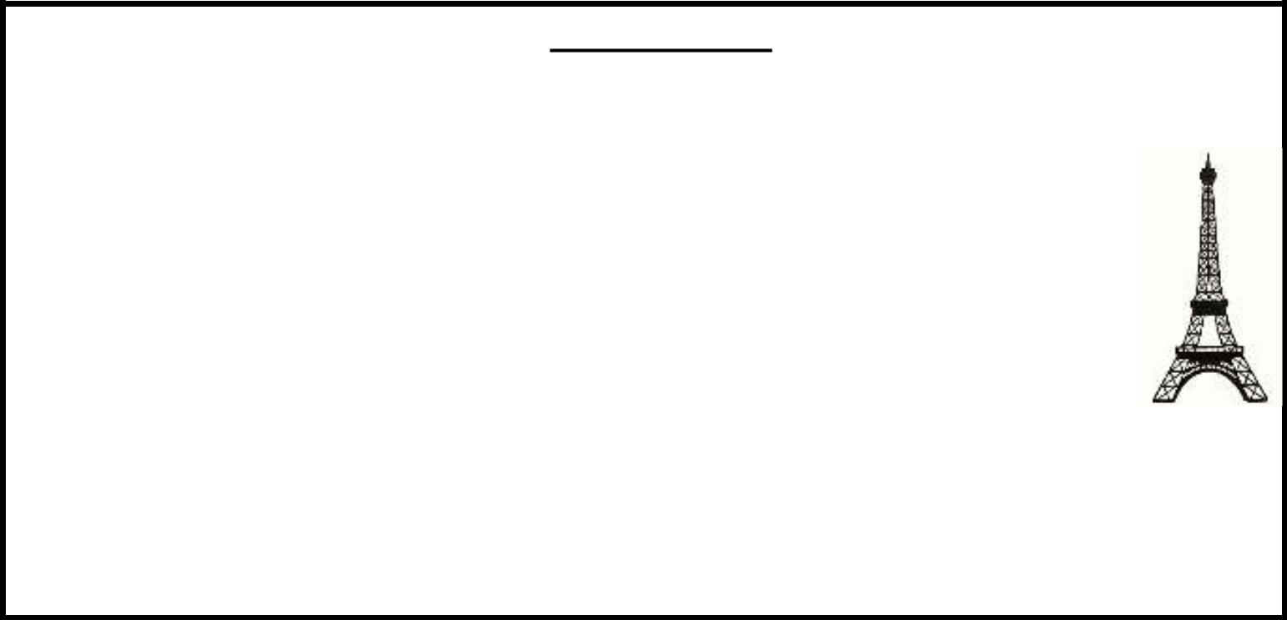

The Eiffel Tower

The Eiffel Tower is one of the most famous building in the world. It is a 324m high structure in the center of Paris, France. Over the years, it has become a symbol of the city and the country. When they built it, The Eiffel Tower was the tallest building in the world. The tower got its name from its designer, Gustave Eiffel, and it build, from 1887 to 1889. The tower opened to the public on 6 May 1889. Today, it is without doubt one of the most recognizable memorial in Europe, one that can be compared to the Statue of Liberty in New York, and the Big Ben is London.

However, soon after opening, newspapers were full of angry letters from people saying how much they hated the new building. This soon changed, and today it is very popular with millions of tourists who visit it every year. You can even find smaller copies of the structure in many cities around the world.

A) Now, answer the following questions in complete sentence:

1- Who was the designer of The Eiffel Tower?


 |  | ……………………………………………
 |  | 2- When did the Tower open for the public?
 |  | ……………………………………………
B) Put ( T ) or ( F ) in front of each sentence of the following:
 |  | 1- When they built it, the Eiffel Tower was the tallest building in the world. ( |  |  | )
 | 2- The Tower is one of the most recognizable memorial in Africa |  |  | ( | )
 | 3- No one can visit The Tower. |  |  | ( | )

- Choose the correct answers:

1- The Eiffel Tower is in ……………………

 | B) France | B) America | C) Italy
2- | The Eiffel Tower is a ……………………..
 | B) 234m high | B) 324m high | C) 342 m high
3- | The Eiffel Tower is a very famous …………………
 | B) station | B) hospital | C) building

- Read the following passage carefully then answer the questions below:


Arabic Coffee

Arabic coffee or (Gahwa) is a very important drink in Saudi Arabia and in the Arabian Gulf countries. Preparation, serving and drinking Arabic Coffee are derived from Bedouin hospitality. Usually, guests are served with Arabic Coffee and Dates.

It is all about tradition, hospitality and ceremony. It's a sign of welcome and marks the beginning and the end of a guest's visit.

It can be served anytime at home, at social gatherings or business meetings. The coffee is served and received with the right hand. The host serving the coffee fills the small cup only half full. As soon as the guest drinks it, the cup is refilled continually until the guest gently jiggles the cup indicating he has had enough ,it is customary to take 2 to 3 cups. Sugar and milk are never added but it is often served with dates.

The trees that produce Arabic coffee can measure over three meters in height. The leaves of the Arabic coffee plant are also comparatively large.

A) Now, answer the following questions in complete sentences:

1- Is Arabic Coffee an important drink in the Arabian Gulf countries ?


……………………………………………………………………………………..

2- Where can Arabic Coffee be served ? mention two examples.

  - ………………………………… B) ……………………………….....

- Put ( T ) or ( F ) in front of each sentence of the following:

 | 1- The trees that produce Arabic Coffee can measure over three meters in height . |  |  |  |  |  | ( | )
 | 2- Sugar and Milk are usually added to Arabic Coffee. |  |  |  | ( |  | )
 | 3- Arabic Coffee marks the beginning and the end of a guest's visit. . |  |  |  | ( | )
F) Choose the correct answers:
 | 1- Guests usually are served with Arabic Coffee and………….
 | A) Dates | B) Milk |  | C) Sugar | D) Salt

2- Preparation, serving and drinking Arabic Coffee are derived from …………hospitality

A) Modern

B) Western

C) Bedouin

D) cultural


3- Arabic Coffee is served and received with the …………….

A) left hand

B) right hand

C) order

D) system.

